Overall Organization
I structured my experiment by using nested for loops. My outermost loop ran 5 times in order to accommodate the 5 trials (using 5 different seeds), then the next loop would go through the values of n. The innermost loop would run the insert or whatever function I was testing, and repeated for the min 3 heap.
Raw Data

Binary Search Tree Building with n = 50000
0.025202
0.03044
0.03304
0.033581
0.037361
Binary Search Tree Building with n = 100000
0.085602
0.099907
0.108737
0.115166
0.122514
Binary Search Tree Building with n = 200000
0.245377
0.281329
0.300008
0.315407
0.327494
Binary Search Tree Building with n = 400000
0.636584
0.710603
0.745808
0.777394
0.812889
Min 3 Heap Building with n = 50000
0.002643
0.001484
0.001483
0.001502
0.001483
Min 3 Heap Building with n = 100000
0.002987
0.002966
0.002961
0.002993
0.002833
Min 3 Heap Building with n = 200000
0.005437
0.004605
0.004569
0.004569
0.00457
Min 3 Heap Building with n = 400000
0.009222
0.009834
0.009184
0.009219
0.009343
Binary Search Tree with n = 50000
0.029185
0.033034
0.035405
0.036217
0.037115
Binary Search Tree with n = 100000
0.079586
0.082608
0.084468
0.085705
0.085302
Binary Search Tree with n = 200000
0.176254
0.182327
0.184936
0.189151
0.189791
Binary Search Tree with n = 400000
0.363333
0.369134
0.371901
0.369851
0.368495
Min 3 Heap with n = 50000
0.326079
0.349583
0.321748
0.314835
0.333473
Min 3 Heap with n = 100000
1.55829
2.28487
2.14783
1.94829
2.47383
Min 3 Heap with n = 200000
12.7179
13.4738
12.4783
15.2874
14.3785
Min 3 Heap win n = 400000
31.4723
27.4738
29.3827
33.8495
30.4821
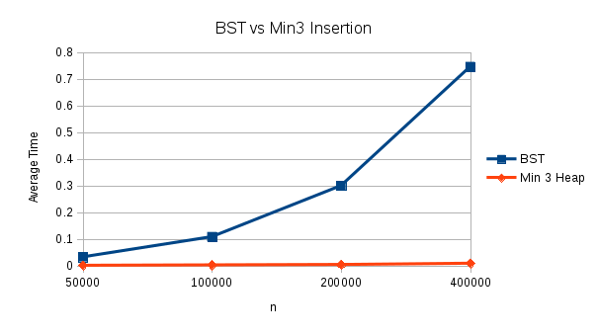
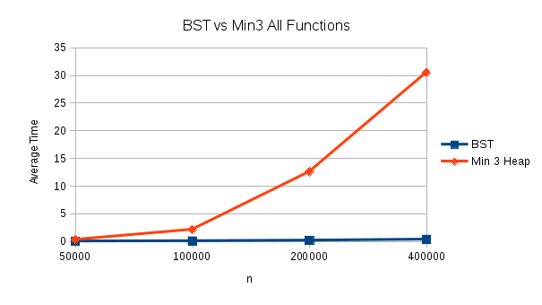
Summary of Results
The Min 3 Heap was very clearly much faster than the binary search tree when it came to inserting, never exceeding one one hundredth of a second even with 400000 values, whereas the binary search tree approached a full second. However, when the other functions were incorporated, the binary search tree’s strengths were shown. The Binary search Tree worked faster with all the functions incorporated than it did when it was only inserts, but the Heap struggled greatly, averaging around 30 seconds with 400000 values.

Observation and conclusion

Binary Search Trees and Min Heaps have distinct strengths and distinct weaknesses. Because of the nature of using arrays to implement Min Heaps, it makes building extremely fast, however when it comes to functions that require a search, it struggles greatly. This is the polar opposite of the Binary Search Tree, which struggled on building, but held a relatively low time when it came to its delete functions.

